Chapter 3, Solution 22

Determine v₁ and v₂ in the circuit in Fig. 3.71.

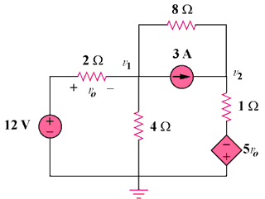

Figure 3.71
For Prob. 3.22.

Solution

At node 1, 24 = 7v₁ - v₂ (1)

At node 2, 3 +

But, v₁ = 12 - v₁

Hence, 24 + v₁ - v₂ = 8 (v₂ + 60 + 5v₁) = 4 V

456 = 41v₁ - 9v₂ (2)

Solving (1) and (2),

v₁ = - 10.91 V, v₂ = –100.36 V

